# Table of Contents

**Table of Contents** **2**

**Introduction** **3**

**Web Design Layout** **4**

Home Page 4

Cleaning Services 6

Products 8

Workers 9

Join Us 10

**Problem Encountered and Solutions** **11**

**References** **12**

# Introduction

We are a company providing cleaning services by the hour by the name of “Round The Clock”.

The objective of our website is to expand our potential market, advertise our services using the Internet instead of printed media and recruit workers through our portal. With the establishment of our website, we are able to reach consumers who are in other states within the country Malaysia and inform them about our existence. Not only that, we are also able to recruit additional workers who live in other areas, which enables us to readily offer our cleaning services to users in those areas.

Our targeted users include those who are too occupied to tidy up their living areas and those who require assistance in cleaning a large house: fresh graduates, house husbands or housewives, working married couples etc.

We will ensure we provide all the information needed and wanted by users of our website. First of all, users will be concerned about the security of their belongings and their personal safety when employing an hourly worker who does not have a reputation. Therefore, we will provide the background information of the worker employed by a user and keep track of the personal details of all our workers, so that sufficient information can be submitted to the police when a report is lodged against any of our misbehaved workers. Besides that, the prices of all services and packages available will be clearly listed out to ease users in comparing us with our competitors.

Designing our website will require us to utilise a lot of information. Firstly, we will use portrait photos of our workers, pictures of certain products like robot cleaners, vacuums and mops and pictures for service demonstration purposes. Our cleaning services will be sold individually and in packages, where they are priced differently. All prices are charged based on the type of service per hour.

# Web Design Layout

## Home Page

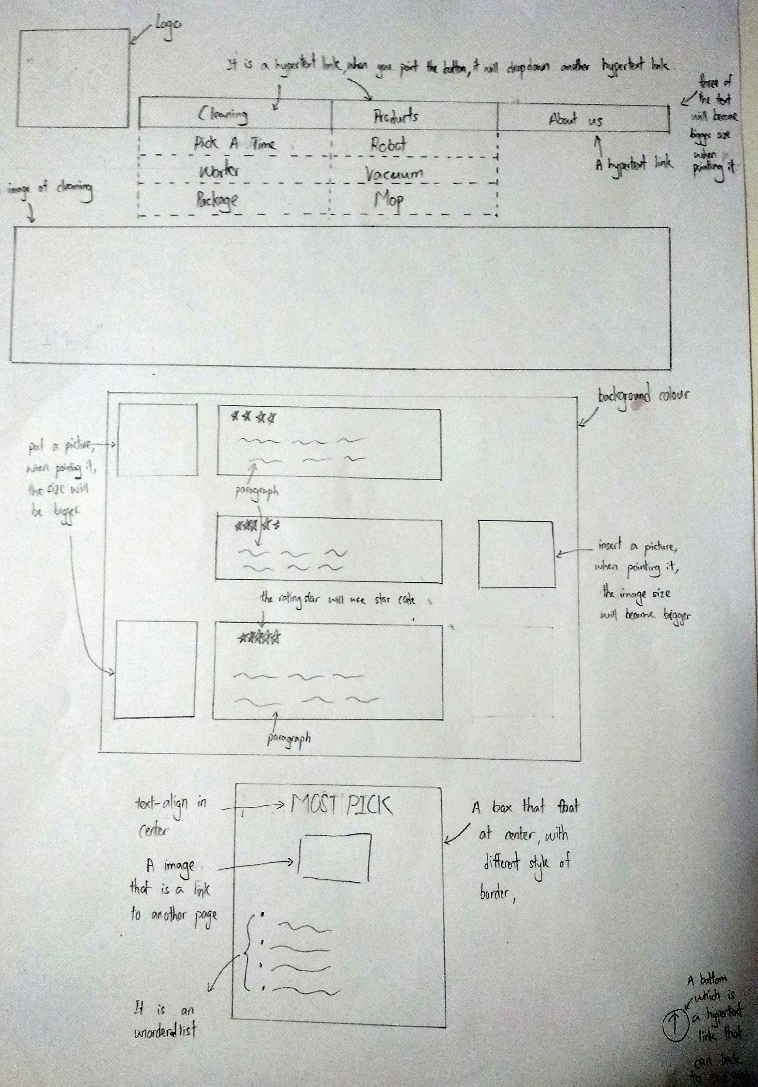

Under the header section, our logo at the top left corner will be hyperlinked to the home page. The navigation bar will consist of five sections (although it is not drawn in the layout): Cleaning Services, Timetable, Products, Workers, Join Us. There will be a drop-down list when the cursor is hovered over the "Products" section, featuring "Robot", "Vacuum" and "Mop". The header section is the same for all pages.

Below the navigation bar, there will be a section of slides of images for illustration purposes.

Two or three workers' profile will be shown below the slides that include a photo, a star rating and a short paragraph regarding the worker.

There will be a "Most Picked" service package section under the worker profiles that consists of an image and list of details.

## Cleaning Services

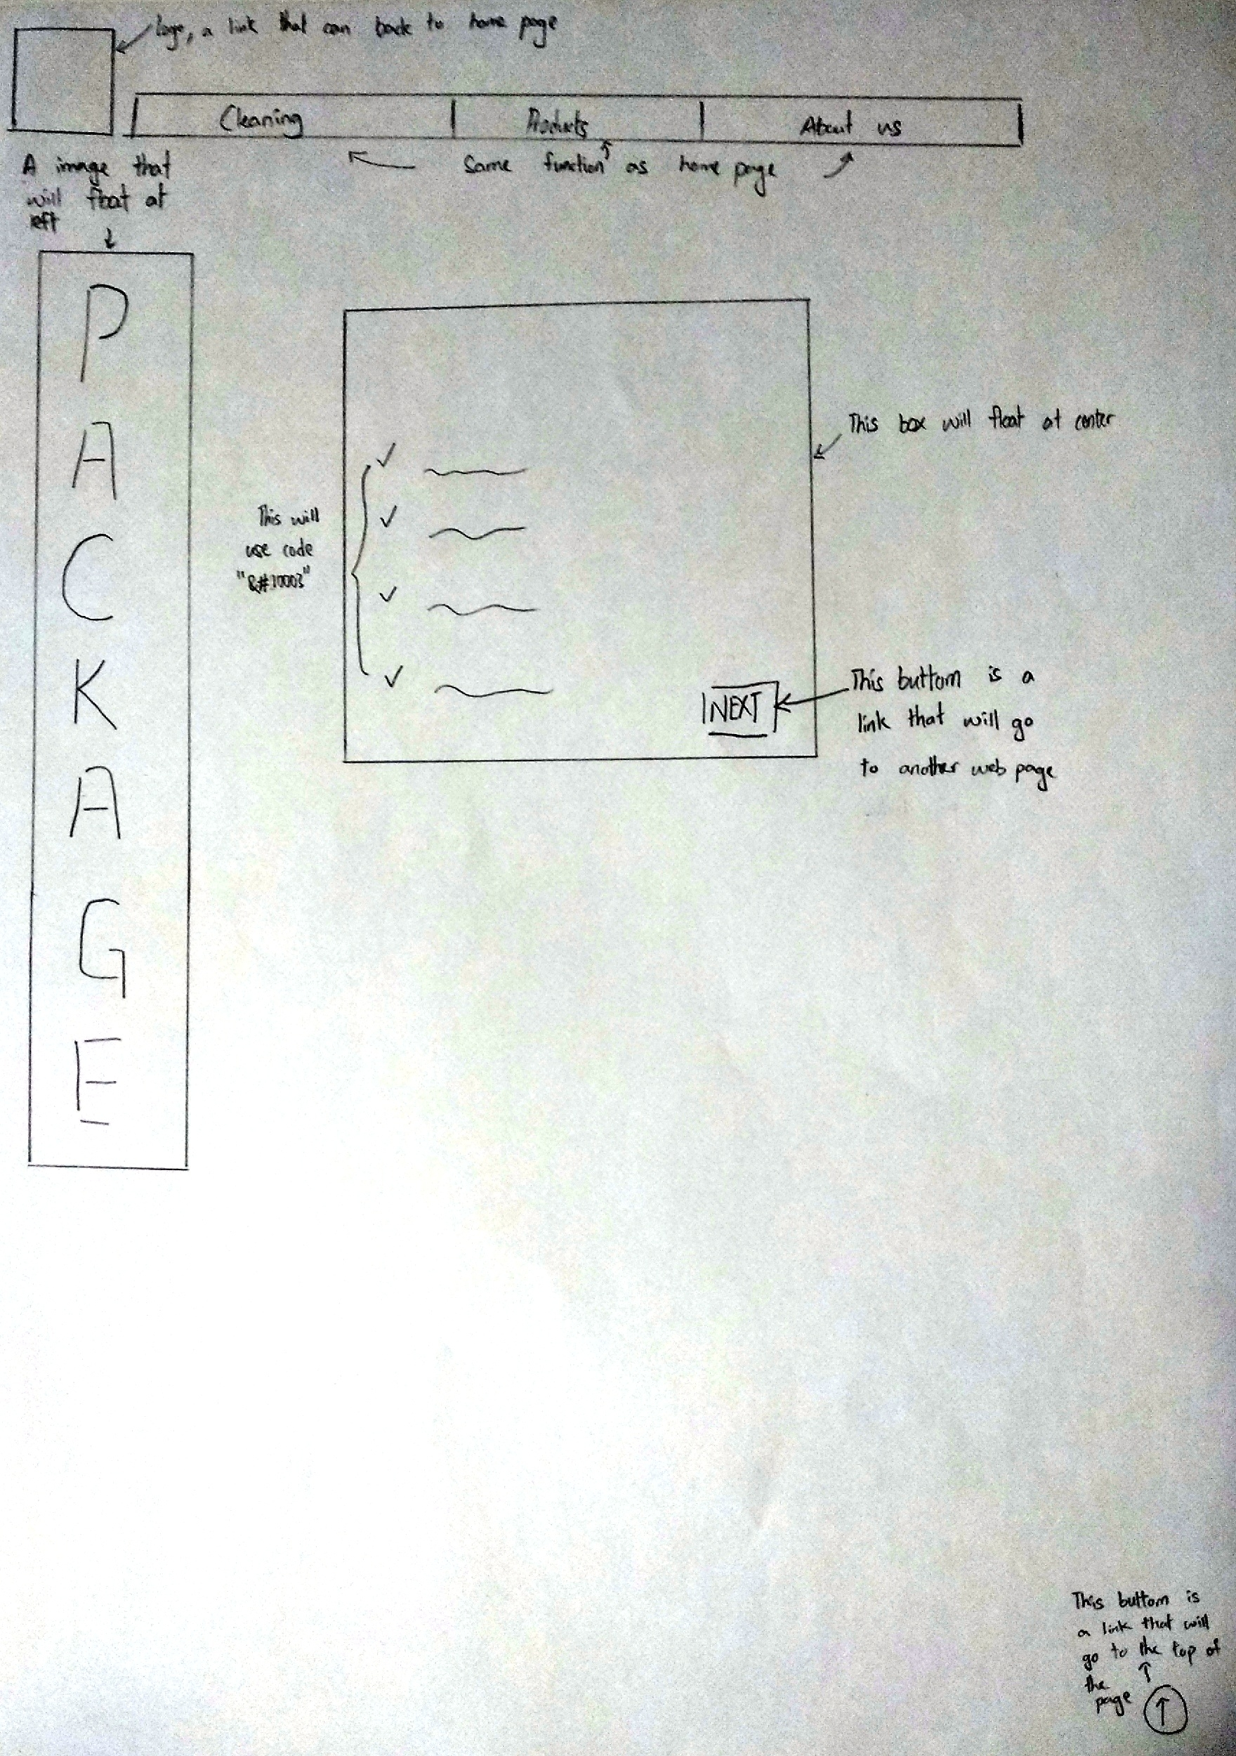

The header is at the top of the page.

On the left, there will be an image that shows the word "Package", while on the right there will be boxes explaining the packages in detail, including price, services and description. There will be a "next" button in every box that leads to the timetable page.

Timetable

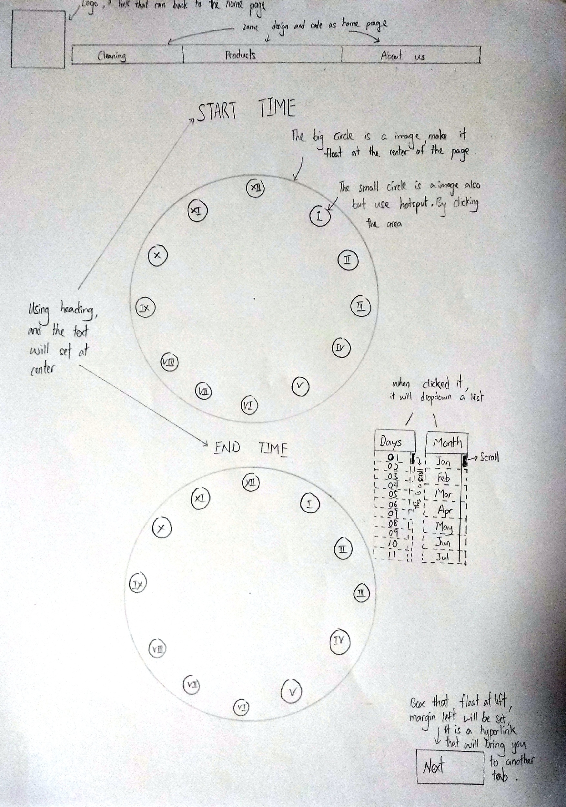

The header section is at the top of the page.

Two clock images will be shown along with a list to choose the date from, and users can select their start and end time by clicking on the images.

A "next" button is placed at the end right corner to proceed.

## Products

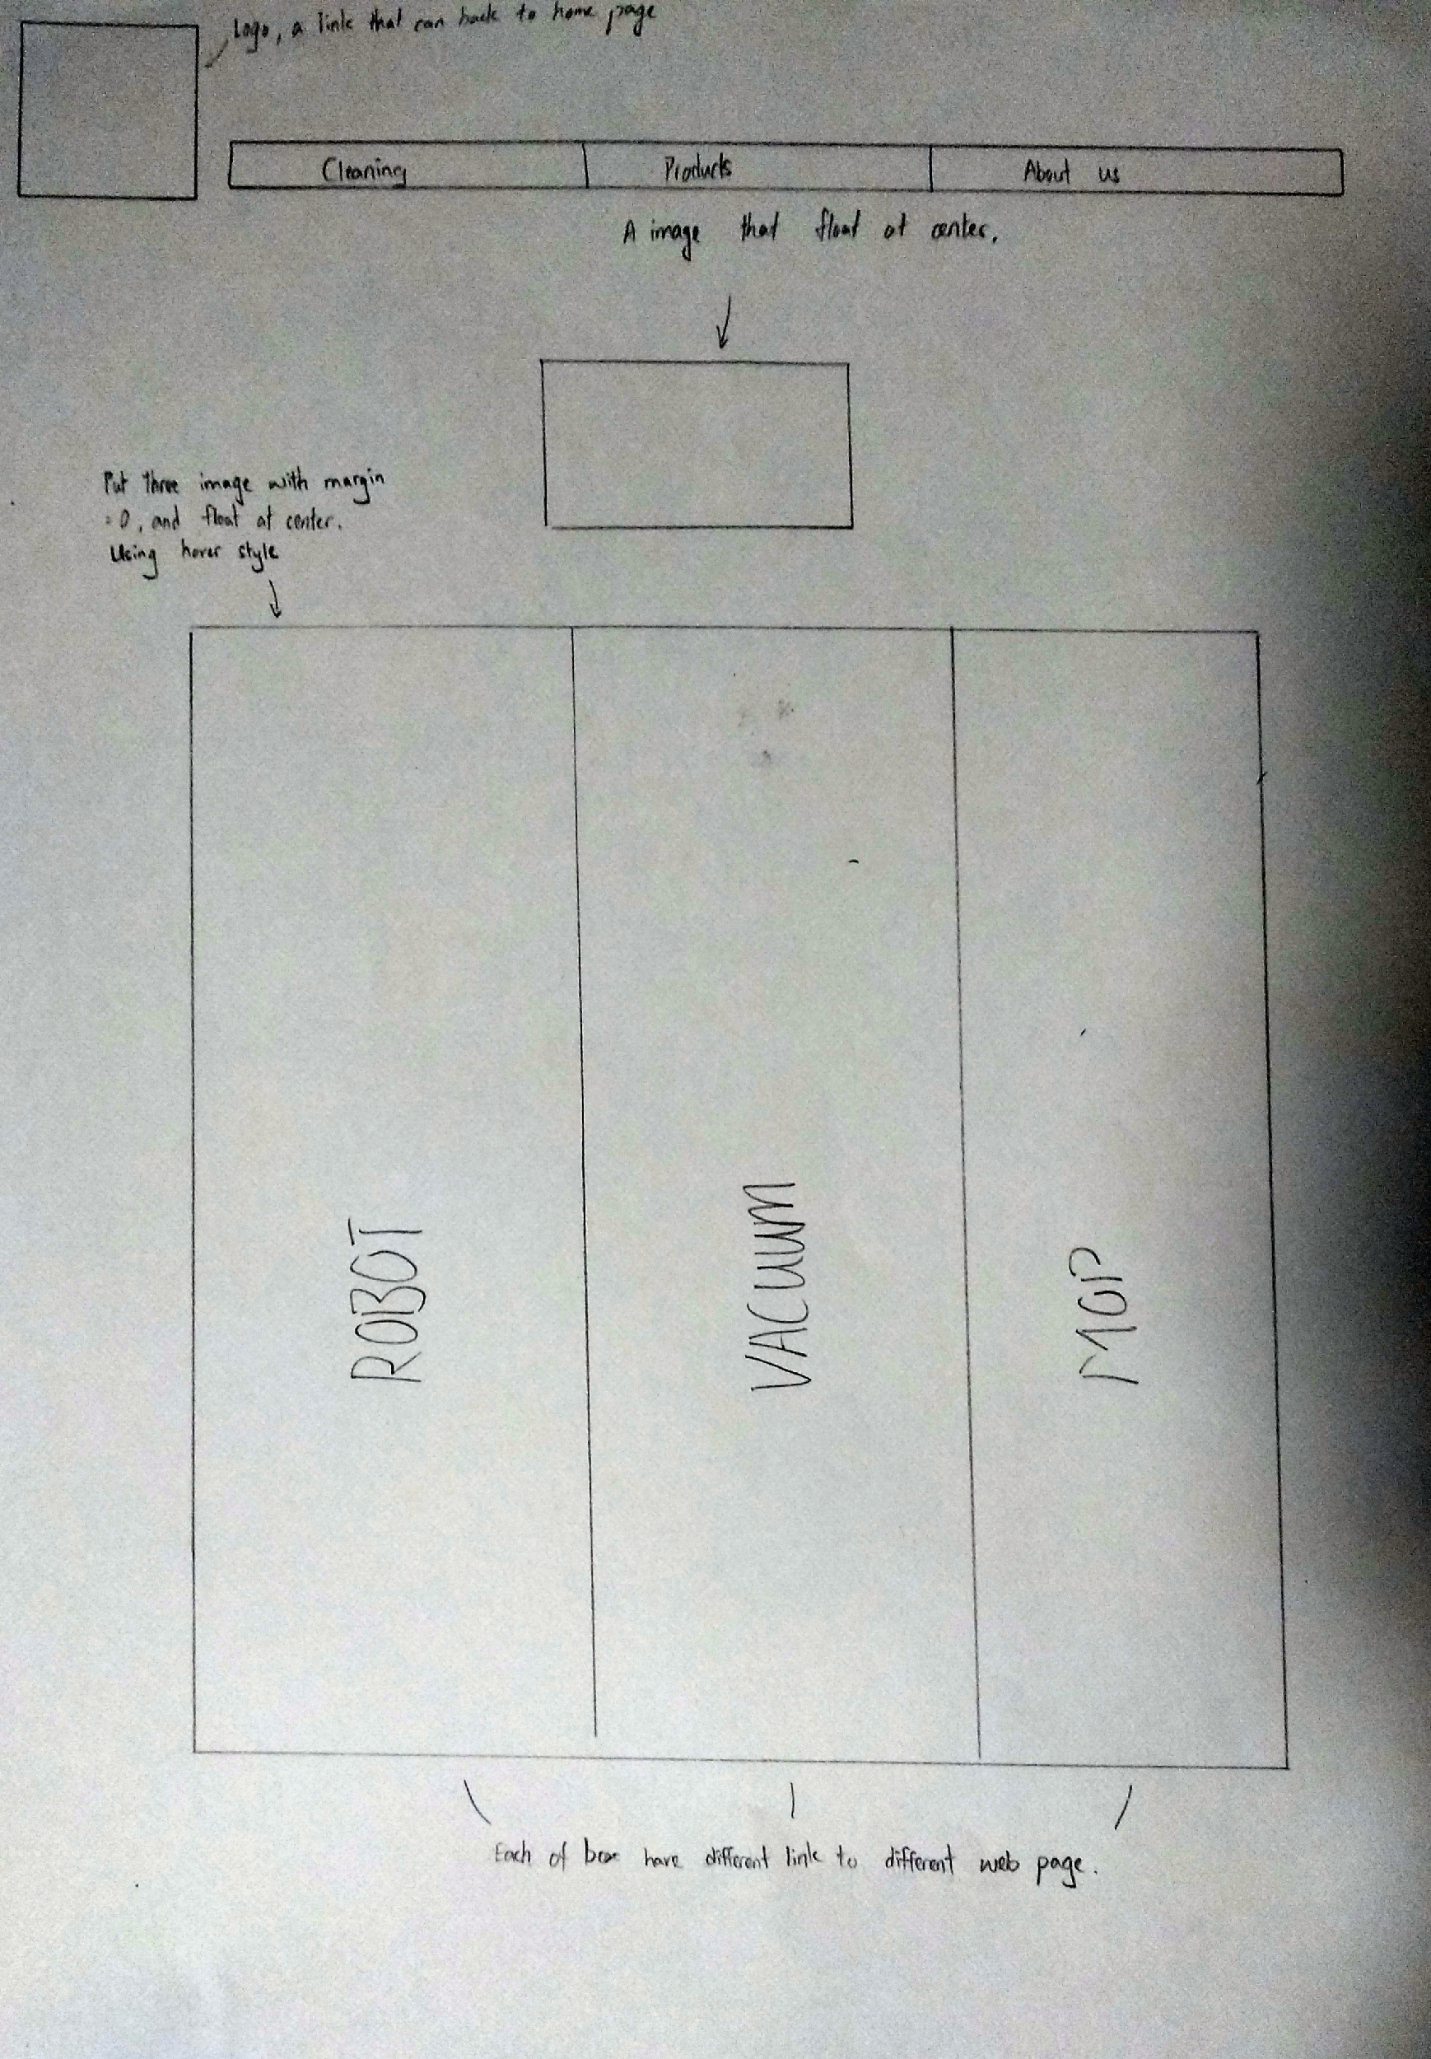

The header section is at the top of the page.

There will be three images that represent the three different categories: Robot, Vacuum and Mop. They will be hyperlinked to show a list of available products.

## Workers

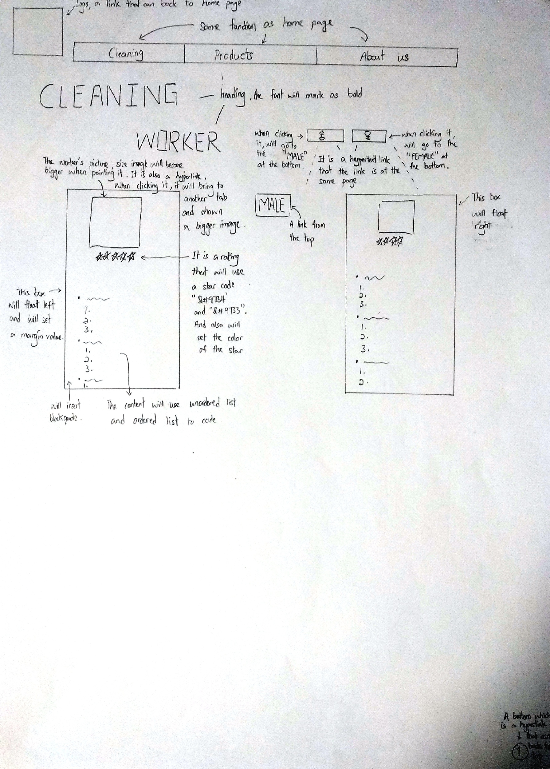

The header section is at the top of the page.

Each worker will have a profile photo, a star rating and a list of the worker's details.

## Join Us

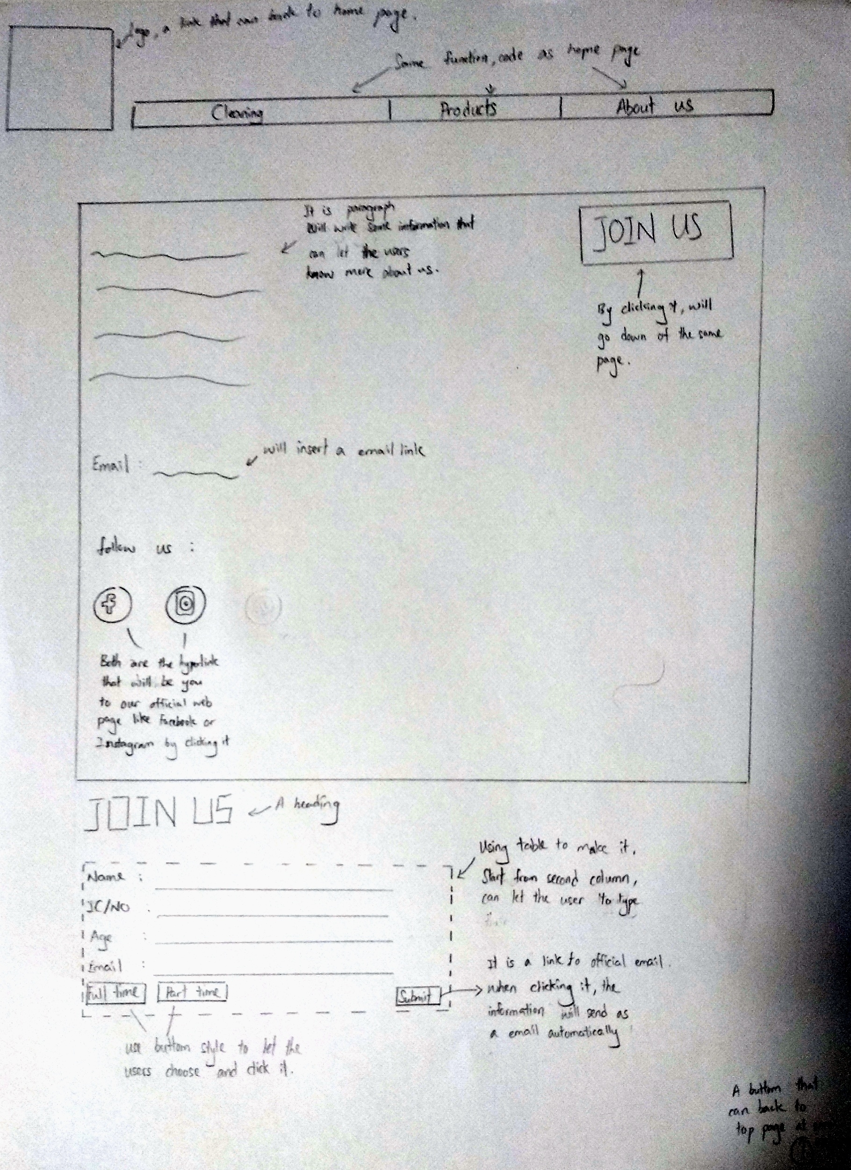

The header section is on top of the page.

There will be a short paragraph that introduces our company and a button "Join Us" for those who are interested to work with us. Upon clicking on the button, it will jump to the bottom part within the same page to a form requiring applicants to fill up and submit their details.

Methods to contact us include our e-mail address, Facebook page and Instagram account.

# Problem Encountered and Solutions

Firstly, the logo we originally designed was an analogue round clock that conveyed an inaccurate impression about our company, inducing users to think of us as a timepiece dealer. Hence, we replaced the hour and minute hands of our logo with a mop and a broom, so that users can clearly infer from our logo that we are a company providing cleaning services.

Secondly, we have inserted many images in our website which slowed down our web page loading speed. In order to speed up the process, we converted the thumbnails into a lower resolution version, only displaying the full sized image upon a click. For example, we used an online compressor to convert a photo of 500 kb to 200 kb.

In addition, as there is too much information we wish to convey to our users, our web page at a glance was messy and cluttered. For a better visual experience, we broke down the bunch of information into relevant chunks and created individual web pages for each section, of which are all hyperlinked together. Instead of cramming the cleaning service packages and time table into one page, we separated these two sections into two separate web pages.

Moreover, when there are too many web pages linked to a website, the time needed for users to go from a certain page to another was too long. It was not user-friendly as the chain of pages increased. Therefore, we designed our website in a mixed structure of hierarchical and linear ones to reduce the amount of clicking to the minimum. In every page we placed the navigation bar, so that users can quickly move to another specific scene. For a certain defined process, we also used an augmenter linear structure by adding a link back to the opening page, rather than linear structure itself.

Lastly, the layout of our website were not able to cater to different browser sizes as it had fixed dimensions. In order to cater to different display sizes, we changed our unit of dimensions in our HTML5 code from pixels to relative percentage. With this measurement, all dimensions of our website are able to change according to various display sizes.

# References

* Mop and broom:<https://www.brandeps.com/search?s=mop>
* Clock:<https://www.freelancer.com/contest/Cleaning-Logo-1418159-byentry-23438697>
* Home page:<https://www.msi.com/index.php> ,<https://www.samsung.com/my/> , <https://www.w3schools.com/css/>
* Code reference: <https://www.youtube.com/>
* Product: [www.amazon.com](http://www.amazon.com) , [www.shopee.com.my](http://www.shopee.com.my)
* Logo: <https://www.brandeps.com/search?s=mop>)
* Images: [www.google.com](http://www.google.com)